Hotel Booking Website Report
Purpose of the Project
The purpose of this project is to create a simple static hotel booking website using only HTML, CSS, and JavaScript.
The website allows users to view available rooms, check contact information, and make a booking request through a simple form.
Technologies Used
- HTML — for structure and content
- CSS — for styling and layout
- JavaScript — for interactivity and form handling
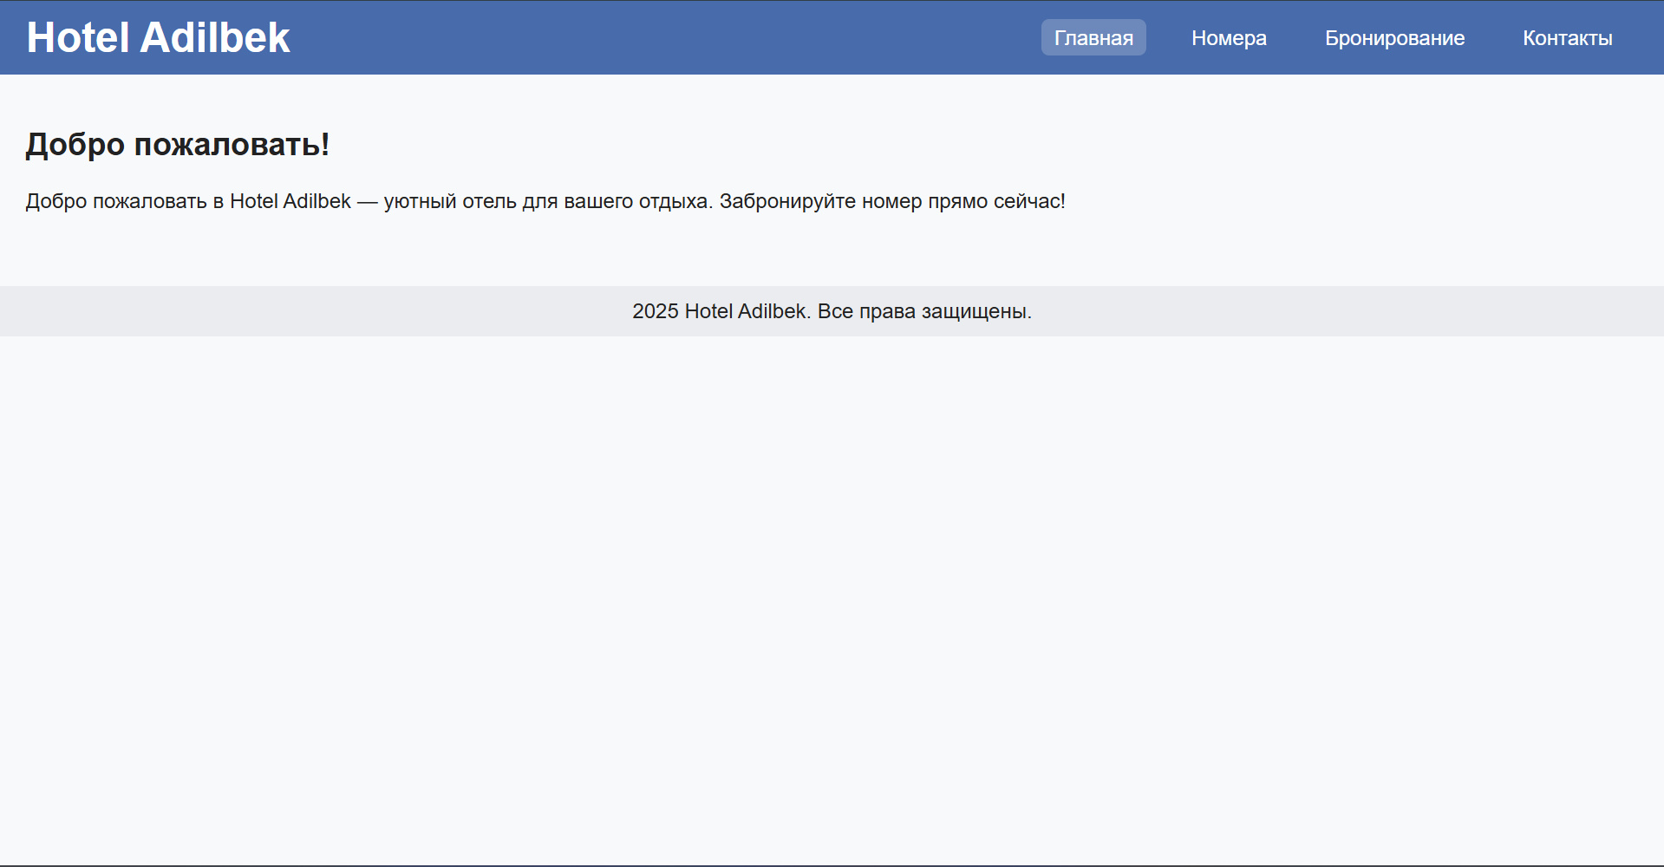
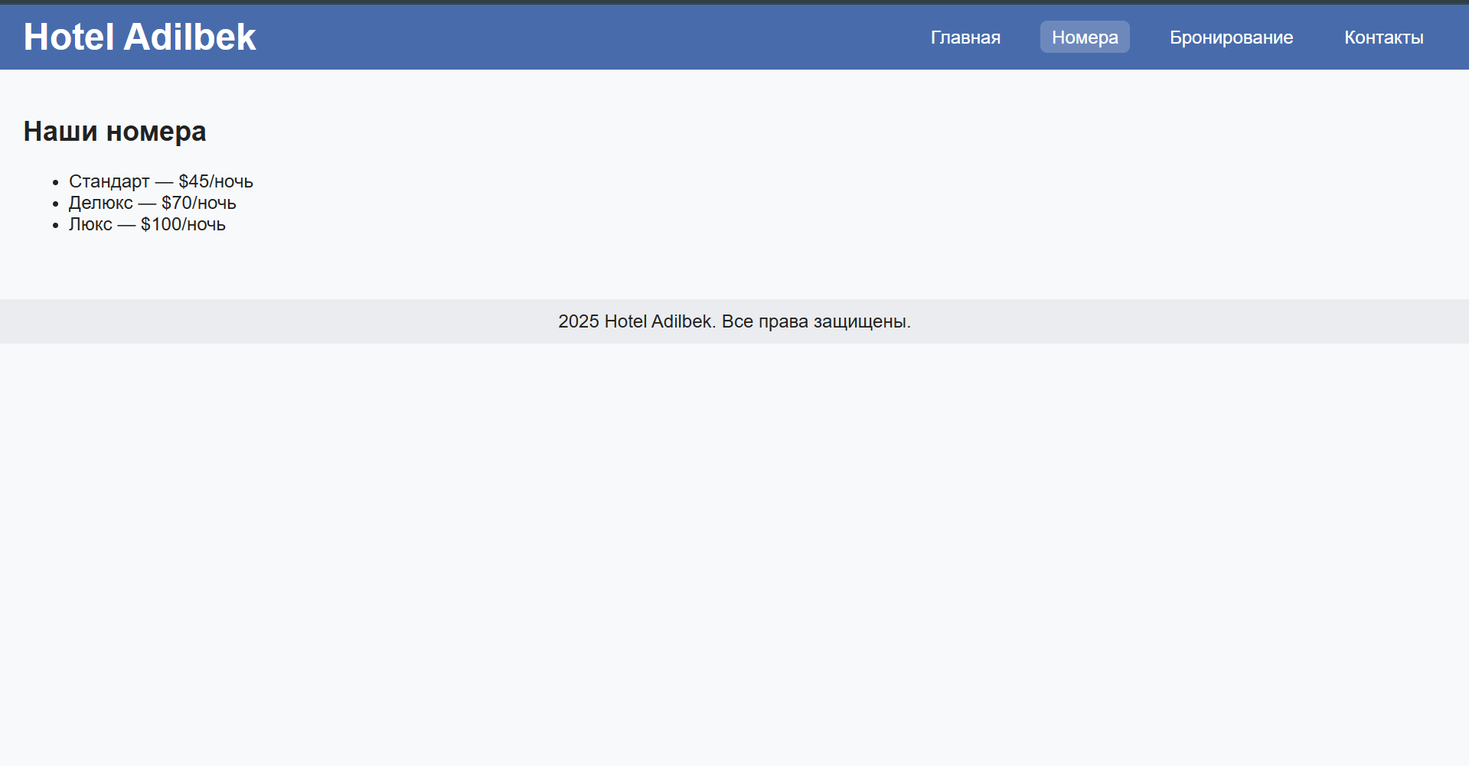
Functionality
- Navigation between pages without reloading (via JavaScript).
- Booking form with required fields (name, check-in, check-out, room type).
- Confirmation message displayed after submission.
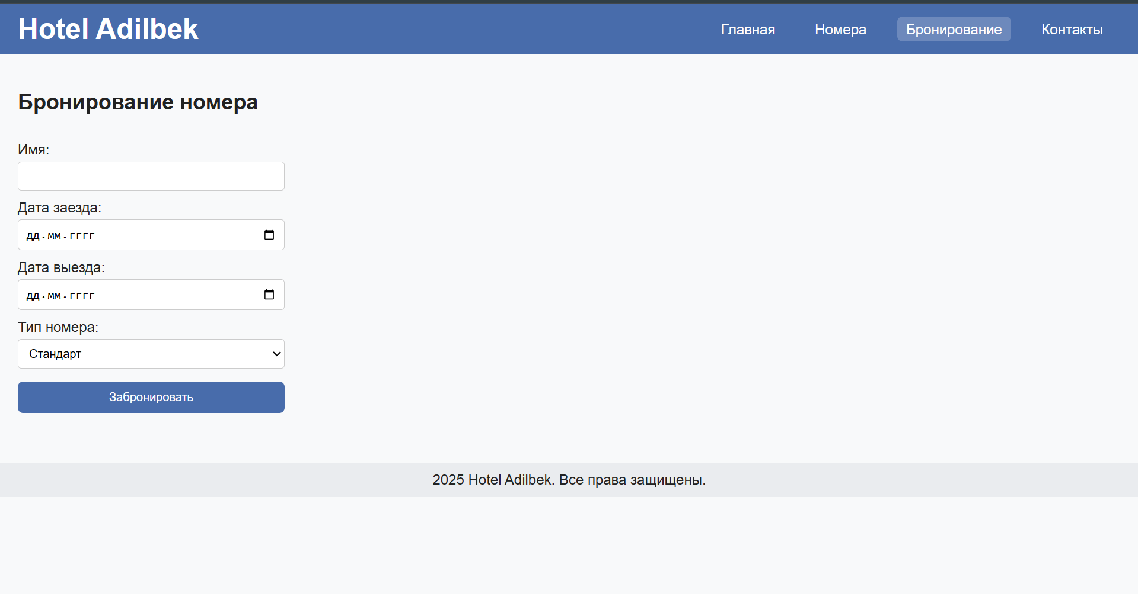
Conclusion
The project demonstrates a basic but functional website for hotel booking.
It can be further improved by adding a backend system, database connection, and responsive design enhancements.

